BeReal Clone: Walkthrough

**Note:** The walkthrough is presented using Xcode screenshots instead of a simulator or video recording due to technical issues with running the iOS Simulator on the iMac in the FIU library. The app is fully functional and runs correctly on a physical device.

This document provides a walkthrough of the BeReal Clone (Part 1) iOS application. Each section corresponds to different parts of the project, with descriptions and related code screenshots.

AppDelegate.swift

Initializes Parse SDK when the app launches.

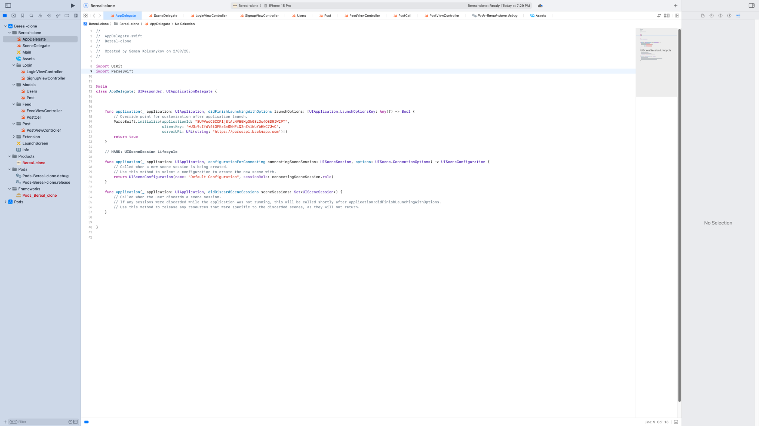

SceneDelegate.swift

Handles login/logout flow and switches root view controller based on user's state.

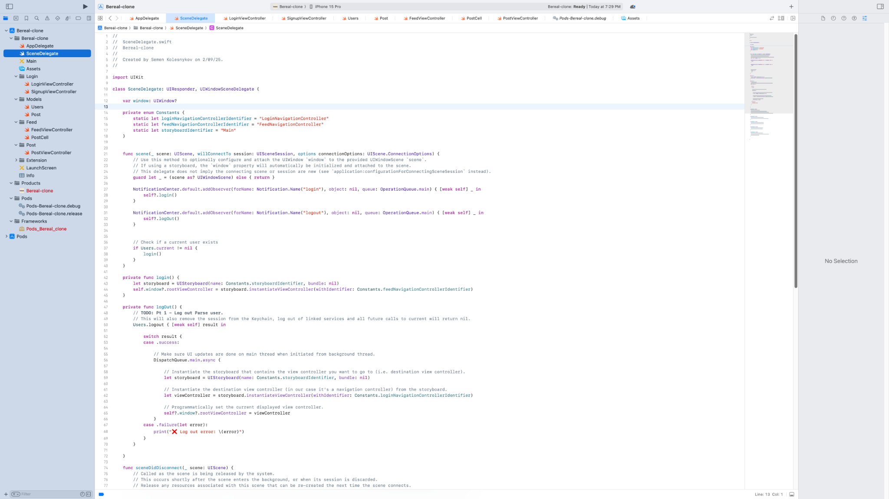

LoginViewController.swift

Login screen where users enter their credentials and log in.

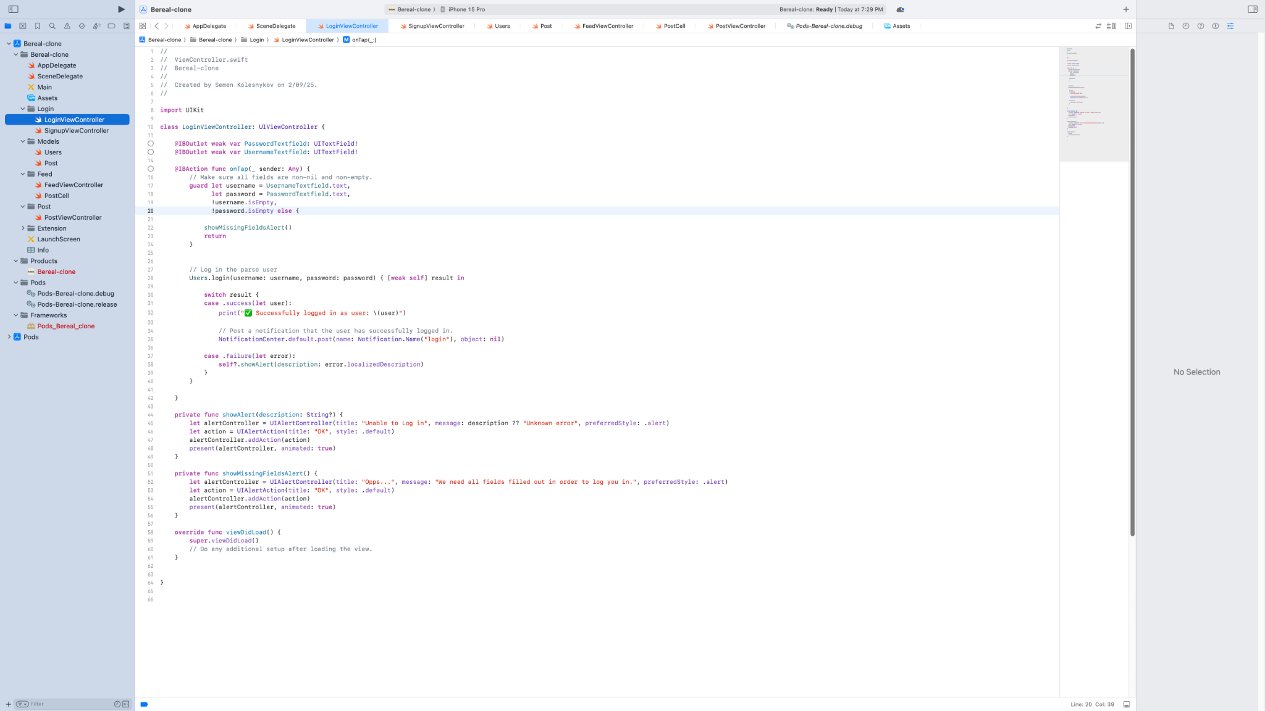

SignupViewController.swift

Signup screen for new users to create an account.

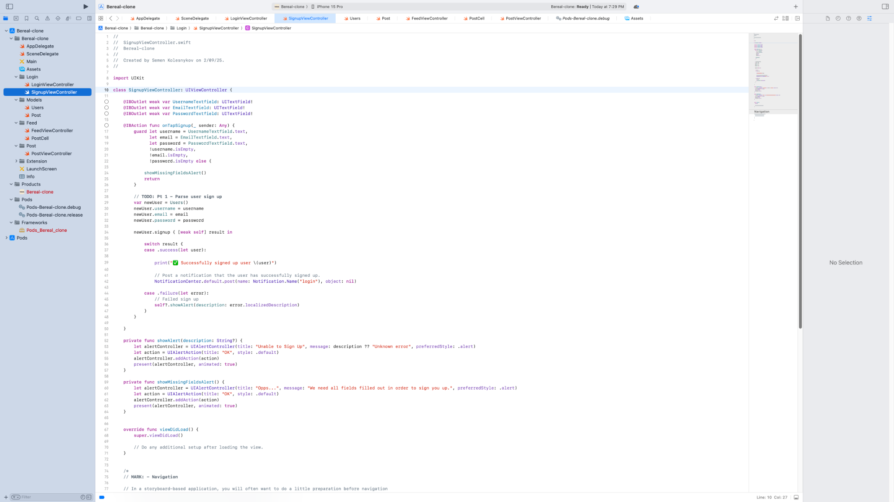

FeedViewController.swift (1/2)

Displays a feed of posts with pull-to-refresh and logout logic.

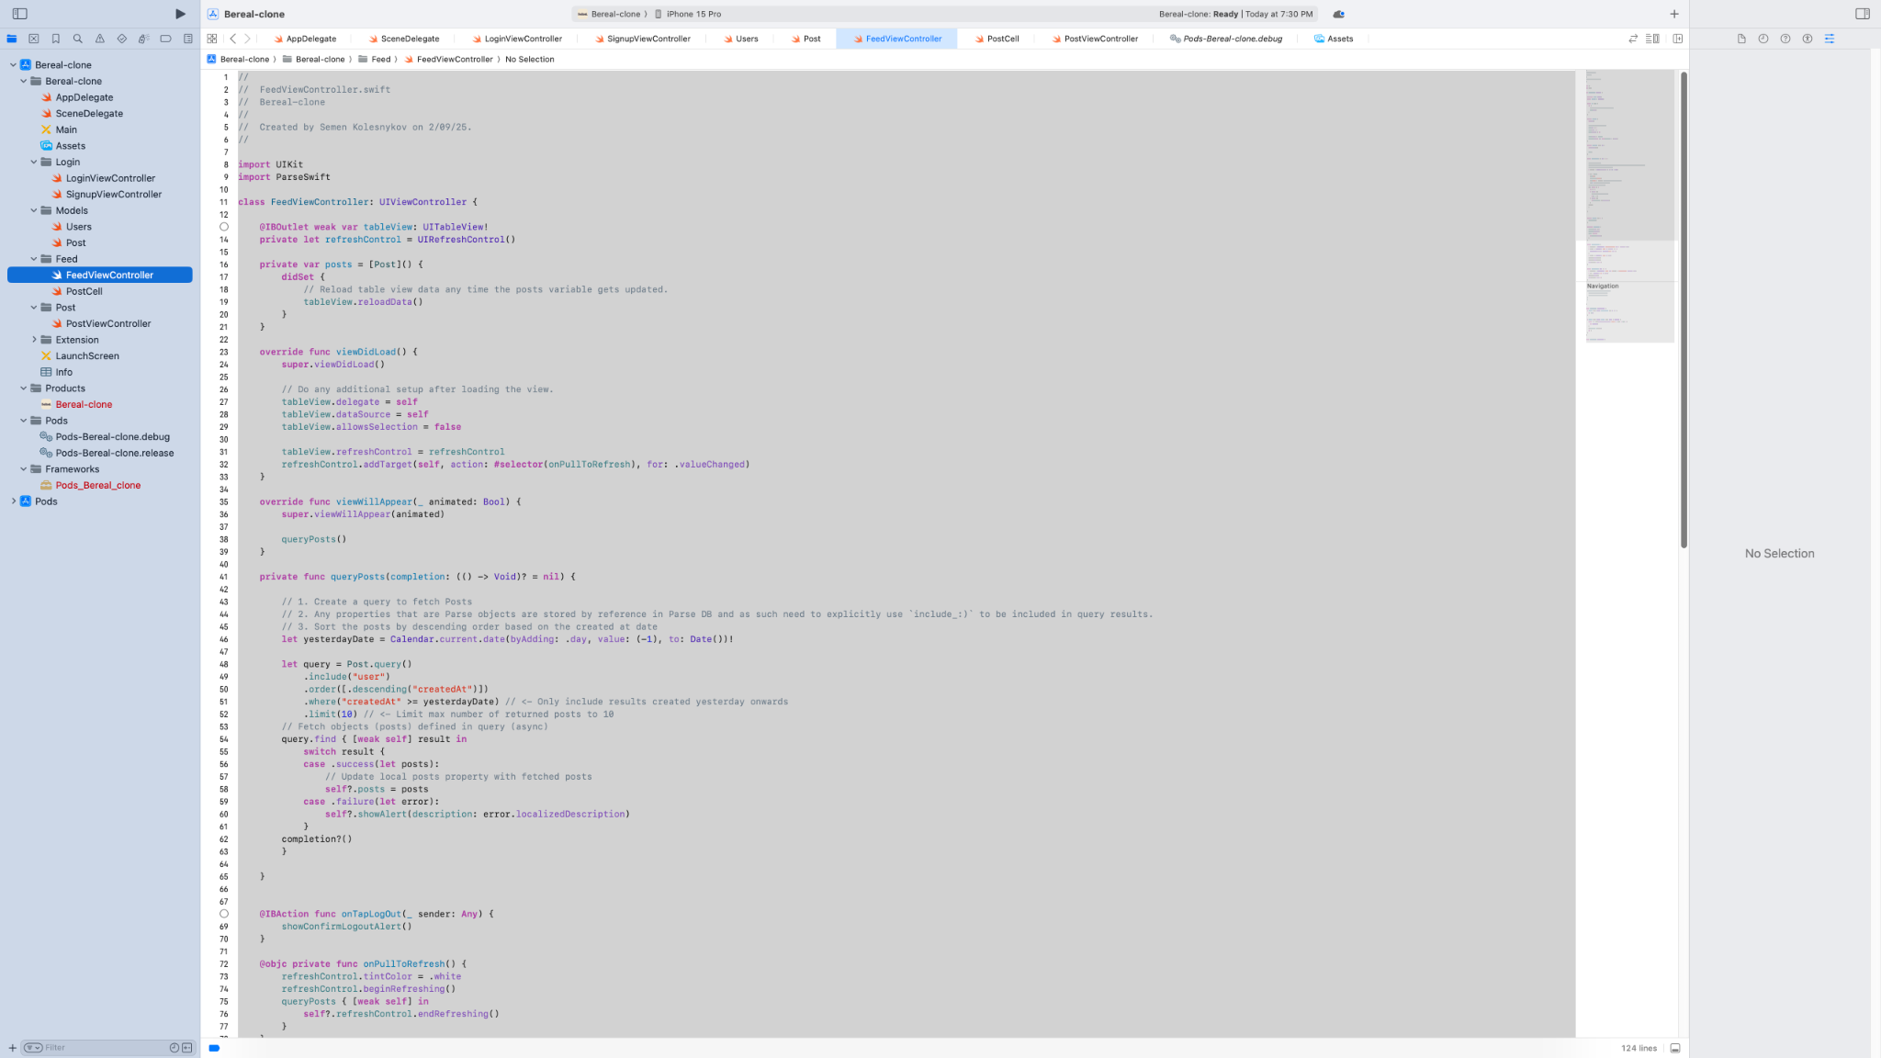

FeedViewController.swift (2/2)

Handles logout confirmation and table view cell configuration.

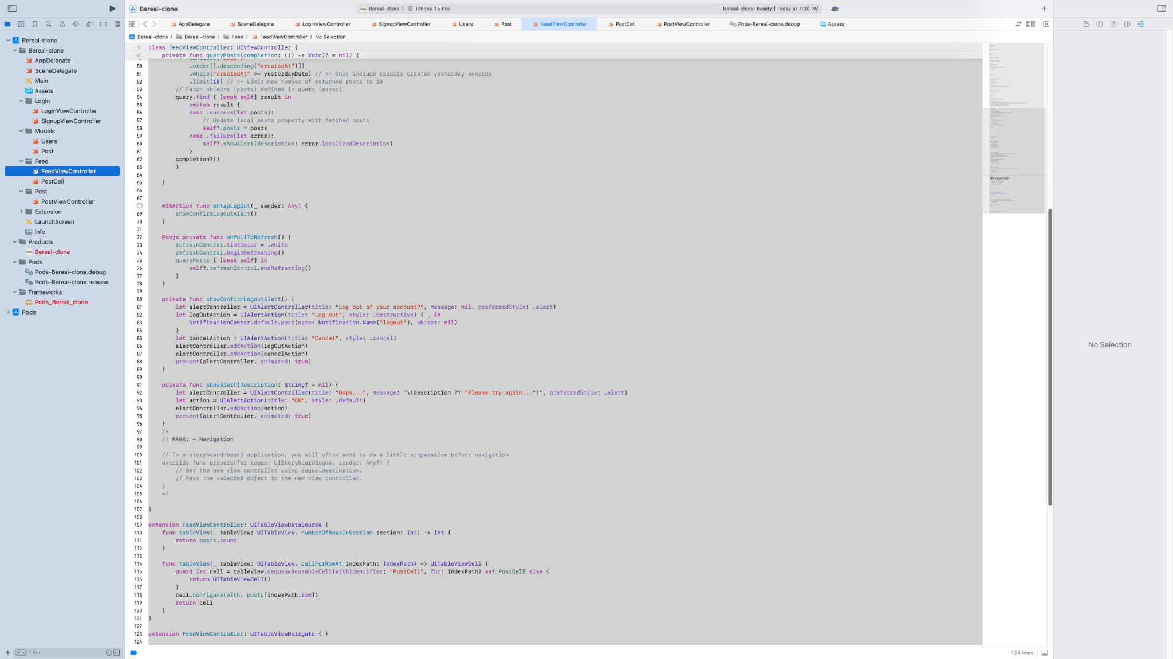

PostCell.swift

Custom table view cell that displays a post, with optional blur effect.

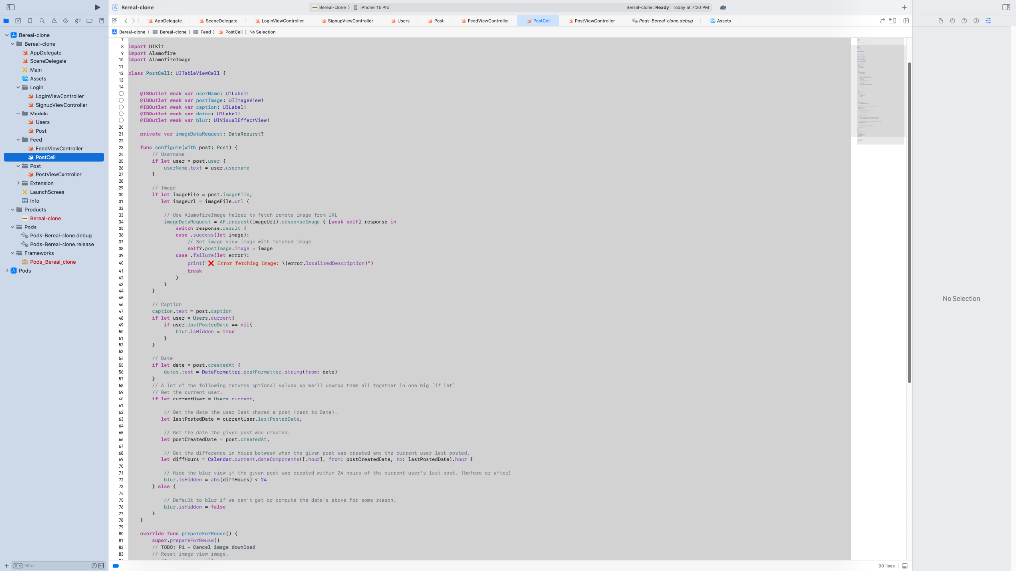

PostViewController.swift (1/3)

UI to pick image and enter caption before posting.

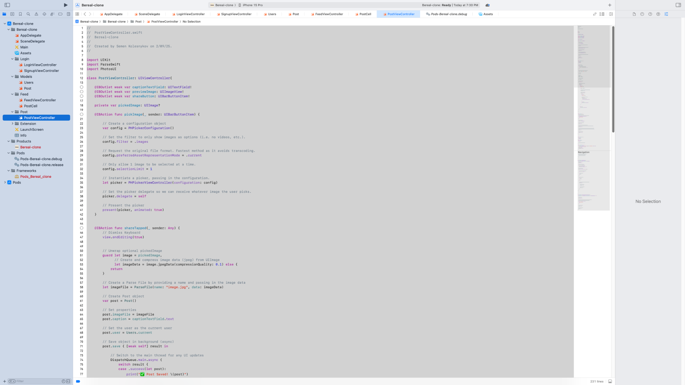

PostViewController.swift (2/3)

Saves the post to the server and updates the user's last post date.

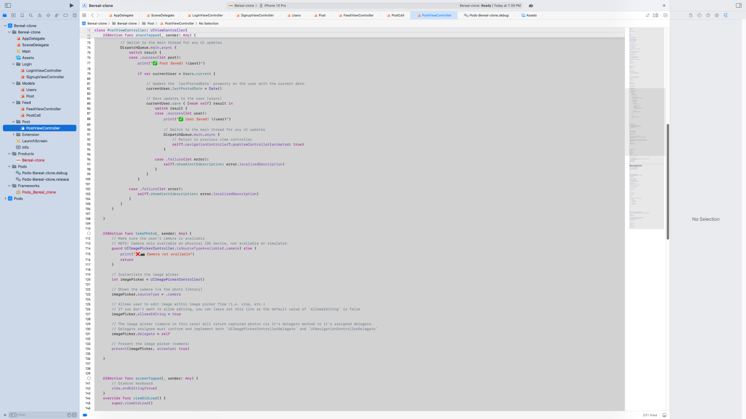

PostViewController.swift (3/3)

Implements PHPickerView and UIImagePickerController delegates.

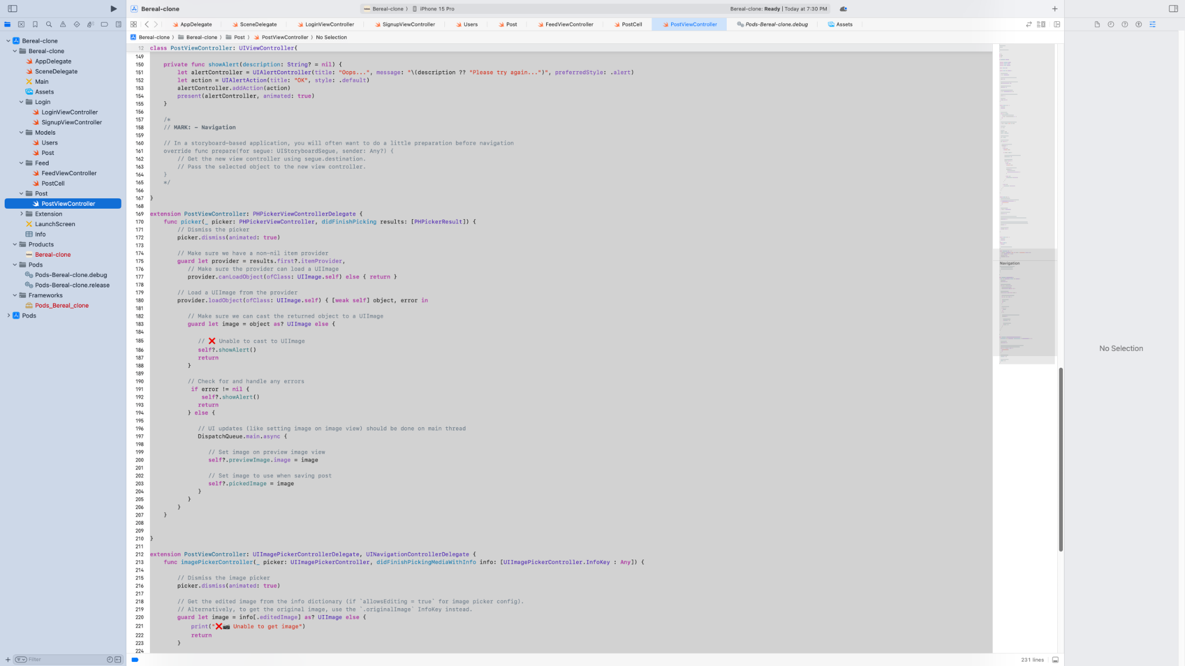

Users.swift

Defines the Parse user model including custom fields.

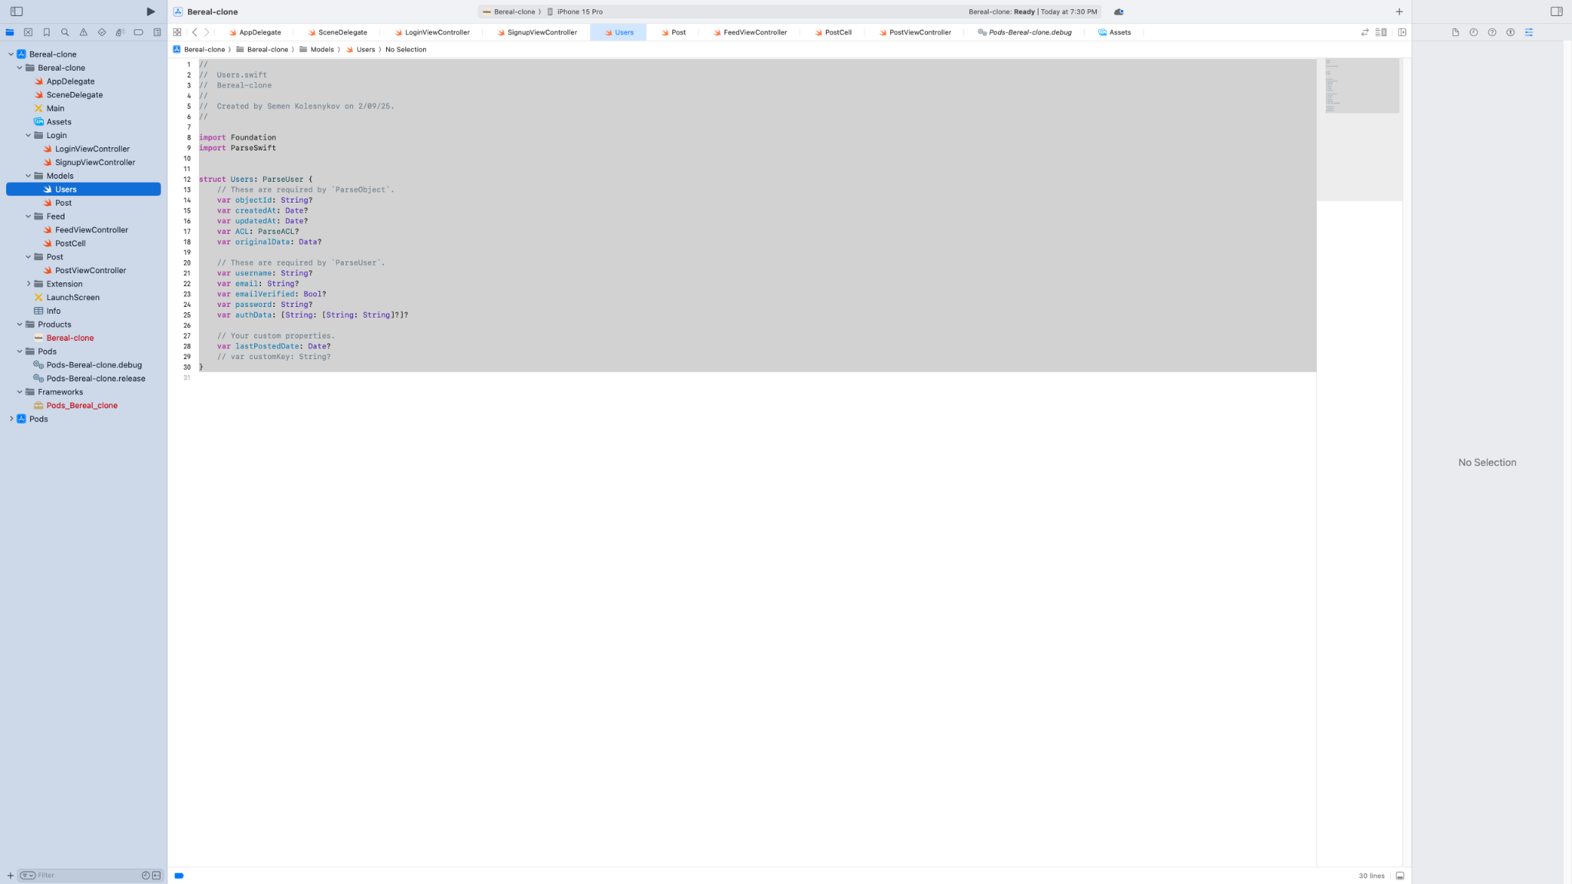

Post.swift

Defines the Parse post model.

